Deceptive Visualization Project Report (Draft): Submitted by Malya Jain

Project outline:
This project consists of analysis of the Consumer Complaints Database of the number of complaints received by the CFPB i.e. Consumer Financial Protection Bureau. This contains the complaints related to financial information such as credit cards, credit reporting, loans etc. The data is segregated on the basis of complaint type, date, company etc.

Data you want to manipulate:
The idea behind this visualization is to identify the major issues which consumers face, state-wise complaints spread, product and the percentage of complaints closed successfully over the timelines 2012-2016. The original and deceptive graphs will be shown in this domain.

Data Source:
https://catalog.data.gov/dataset/consumer-complaint-database#topic=consumer_navigation

Project Book:
- Data Understanding:
  - Understanding the data and relevant fields for this deceptive visualization, removing the redundant and incomplete data, adjusting the fields as per requirements and analyzing calculated fields
- Data Cleansing:
  - Identification of the relevant data fields relating to the idea behind the deceptive visualization
  - Emphasis on the key attributes in order of increasing importance such as the consumer complaints on issues, company and its location, category of product, sub product and mode of submission
- Calculated Fields:
  - Identifying the calculated fields such as delay in days for responding to the issue
  - Year on year percentage increase or decrease in the number of issues per company and issues per product
- Identifying the type of analysis for creating a dashboard
  - Number of complaints per product which shows which product has the maximum and minimum number of complaints
  - Number of complaints per issues which shows which issue is most common and needs to be worked upon
  - Forecast for the number of complaints per issue and per product in 2017
  - Delay in the number of days in responding to the complaint which can give an insight on which company has the most delays in responding to and resolving the issue
  - Location wise analysis of top issues and associated zip codes to measure the efficiency of the workers
  - Presenting the YOY change in the top 10 issues per company
  - Presenting the YOY change in the top 10 issues per product

- Graphs created in Tableau workbook:
I have just done the analysis for the year 2012. Once the graphs work well for this year, I would go ahead and combine the analytics for the subsequent years as well.

- Number of issues per zipcode
The idea behind this sheet is to highlight the number of issues in 2012 mapped to the zipcodes. The orange to blue diverging color tells the population of that zip code so it is easier to see the correlation of the population density and the consumer complaints. Further, clustering the number of issues into two so that it can be selected from the filter in the sidebar. A slider is available presenting the number or count of issues for that zip code and the cluster changes its dimensions according to that.
Point of Deception:
- It is unclear as to how the graph is trying to show the correlation between the population and the number of issues
- Note that number of issues is not a correct representation of the number of consumer complaints
- The color scheme used to the clusters and population is similar but inverse, hence one tends to get confused with how to correlate the two parameters
- From this graph it shows that zip code 33071 FL has the maximum number of issues which is not a clear representation of whether the number of complaints were 548 or the number of distinct issues were 548
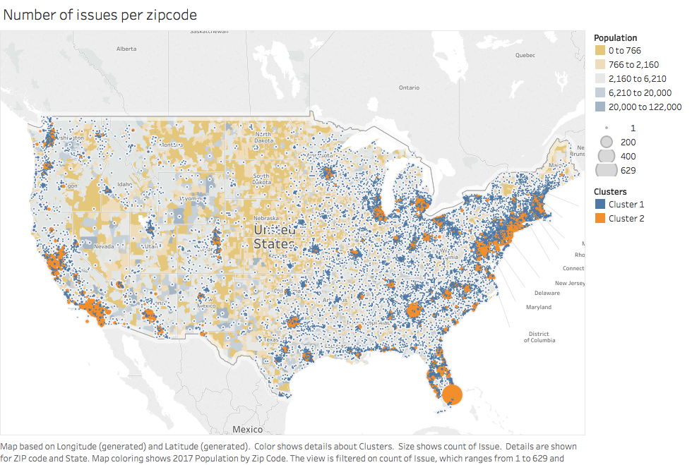

- Number of complaints per state
This graph shows the count of distinct complaints per state. This view is again clustered in color so that it the states are highlighted basis the number of complaints.
Points of Deception:
- It shows that California has the maximum number complaints in the year 2012. However, it does not give any other details or analysis such as why California is ranked the highest, is it due to population or the location of banks in that state
- The color scheme is unclear as the states with minimum number of complaints are highlighted in red

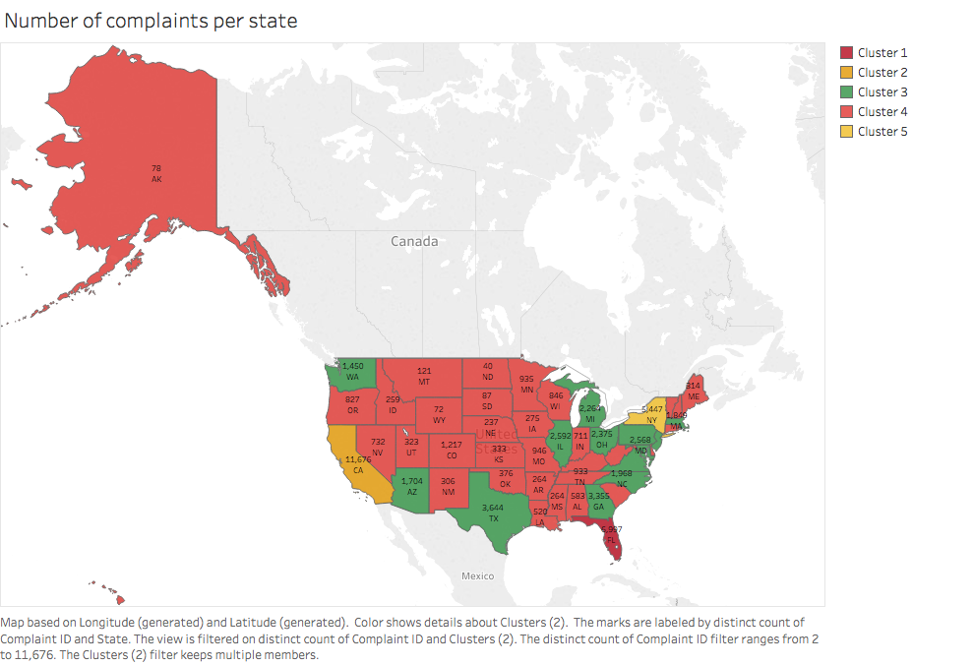

- Complaints per bank & mode of submission
This graph shows the distribution of complaints per bank and also highlighting the mode of submission of the complaint. The slider bar shows the number of complaints and can be filtered on that basis. Further, the submission mode is filtered on the basis of color.
Points of deception:
- The radius of the circles is constant which does not give a clear idea about the number of complaints per category. Only when one hovers over the graph, it shows the number of complaints in that category
- The circles are also overlapping confusing the audience for the number of complaints per submission mode. For example for Bank of America, 254 complaints were submitted via Fax whereas 1,222 complaints were submitted via phone. But since the circles overlap, it seems that the submissions via phone has much lesser complaints as compared to Fax.
- A better analysis of this graph would be to present the percentage points per submission mode for a particular bank (Assistance required to create that calculated field in Tableau)

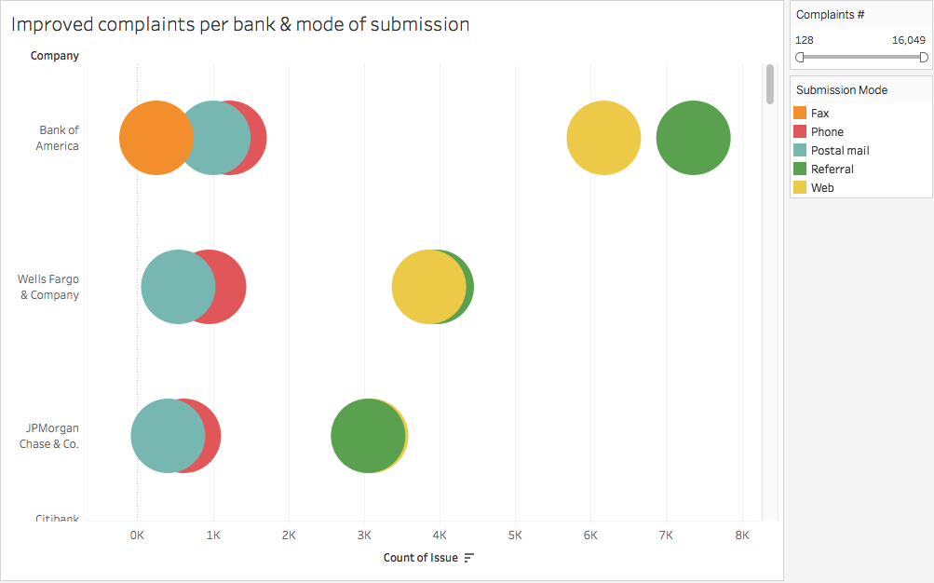

- Timely response of complaints
This graph shows the number of complaints per company for different modes of submission which were responded to in a timely manner. The small circles represent the complaints which were not responded to timely and the bigger circles show it was responded timely.
Points of deception:
- This graph does not solve the purpose of its existence. From looking at the graph, one can easily see which category has the maximum number of complaints per submission mode and also see that most of the complaints were responded to timely. However, it does not give a clear picture of percentage of complaints responded timely.
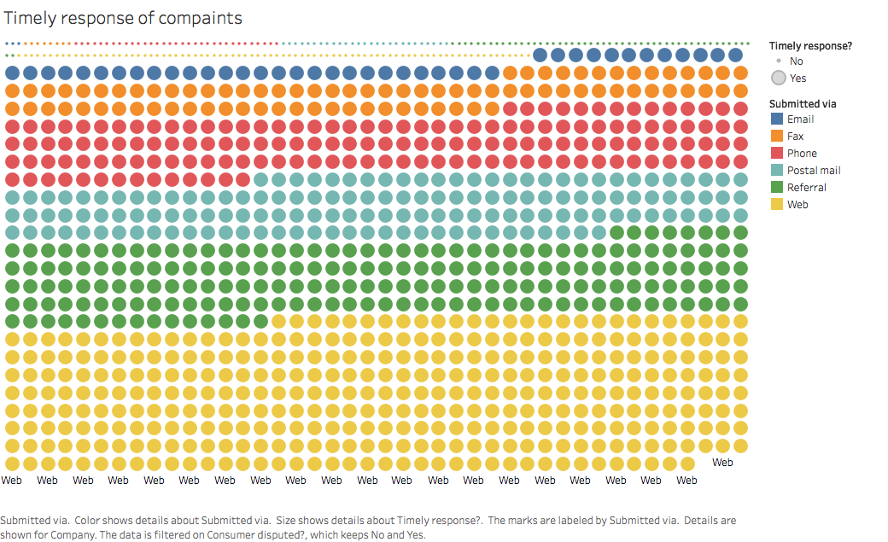

- Average delay in response to the complaints
This graph shows a small heat map for the top 10 types of issues that come up in complaint and the related product. The area in the heat map shows the average delay in the number of days that the customer support executives take to resolve the issue.
Points of deception:
- This graph solves it purpose, however, only for the category that shows the maximum area in the heat map
- The filter presented for mode of submission gives names and not the colors that can help the audience clearly relate the category

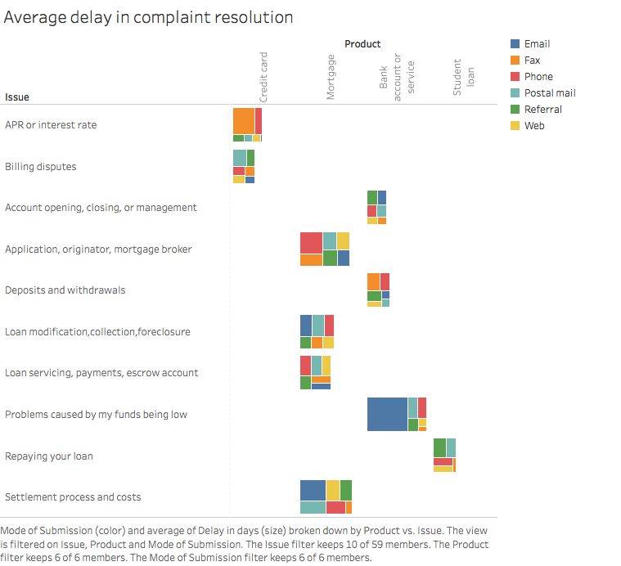

Discussion with professor:
What do you want to show:
- Controversial data
- If you want customer service – go to a smaller bank?
- Scale down the data
- Two categories – national banks and regional banks
- National banks – so many complaints
- Many complaints go to small
- Big ones have far more complaints – all those petty complaints
- Small banks have big complaints – marketing claim
- Start a deceptive version and go about drill down and portray the right one\

